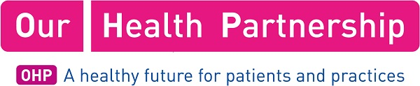
PCN Name: | Northfield Alliance PCNs (x 3)
Job Title: | Clinical Pharmacist
Salary: | Employed (Band 7-8 AfC equivalent) or Contract for Service -Rate will depend on experience and skill
Accountable to: | PCN Clinical Director and Consultant Pharmacist (OHP)
Description
We are seeking Clinical Pharmacists to join our growing team at Our Health Partnership, working with the three Northfield Alliance Primary Care Networks (PCNs).

The post holder will work for and across the Primary Care Networks of 122,198 patients in Bournville and Northfield, Quinton and Harborne and Weoley and Rubery PCNs in the South of Birmingham.

The successful candidate will be part of a dynamic and forward-thinking team of clinical pharmacists employed by Our Health Partnership, working in the nine PCNs across Birmingham. Professional Leadership will be provided by the Consultant Pharmacist at OHP.

We are looking for pharmacists, who can develop and manage medicines optimisation services within our practices. Demonstrating improvements in value and patient outcomes and contributing to reducing health inequalities through the safe and appropriate use of medicines. This includes implementation of systematic processes for improving medicines optimisation across PCNs and the wider OHP, conducting systematic medication reviews, medicines reconciliation following transfer of care and advice on polypharmacy for all patients including those residing in care homes. Work programmes will be prioritised according to the population needs of the PCN.

Please see attached Job Description for further information about this post. If you have any questions regarding this vacancy, please contact Clair Huckerby (Chief (Consultant) Pharmacist Our Health Partnership: Clair.Huckerby@OurHealthPartnership.com )
How to Apply
Please forward a covering letter and CV including details of references
Contact Name: | Clair Huckerby
Contact Title: | Chief (Consultant) Pharmacist Our Health Partnership
Contact Email: | Clair.Huckerby@OurHealthPartnership.com
Contact Telephone: | 0121 422 1366
Contact Address: | Highfield House,  88 Highfield Lane,  Quinton,  Birmingham,  B32 1QX
Closing Date: | 31st January 2020

