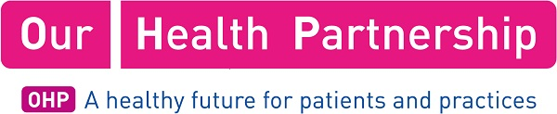

Proposal to Our Health Partnership – initial approach proforma

Introduction

OHP receives many proposals and requests for ‘partner time’. We welcome these, and indeed are keen to encourage ideas and development proposals from partners, member practices and external organisations.

This proforma is to help OHP Board members assess all approaches for Board time and resource, and respond appropriately. As an initial ‘screening’ document we only require outline information at this stage

Scope

This proforma covers all approaches to the OHP Board, including (but not only):
• Ideas and proposals for developments from partners and member practices
• Approaches from commercial organisation regarding products or services
• Requests from NHS or other organisations for OHP involvement in particular initiatives
• Requests to come and address the OHP Board

Actions

We may signpost you to an existing group or workstream, eg our Buyers Group, or we may wish to consider your proposal at a Board meeting. It is possible we will ask for more details at this stage. As OHP is a distributed organisation, committed to maintaining local practice autonomy, we will only take on initiatives centrally when appropriate and when resource allows. In the main, these will need to fit with our strategic priorities of supporting strong local general practice, and developing a wider service offering.

Completing the proforma

Please put in information in all appropriate sections. The form should not be longer than two pages when complete. Please do not feel obliged to enter information in each section. Once complete please email to: info@ourhealthpartnership.com

Your proposal

Working title

…

Proposing organisation or individual

…

Description of proposal, including expected timescales

…

Strategic context

…

Resources required

…

Response sought from OHP

…

Contact details (email preferred)

…

Other relevant information

…

