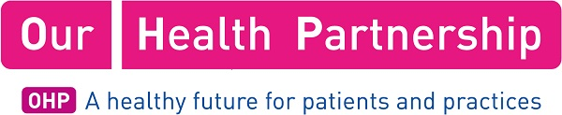
Surgery Name: | Ridgacre House Surgery & Nechells Practice
Job Title: | Associate GP Partner
Salary: | Competitive rate (to be negotiated)
Description

Ridgacre Medical Centres https://nchp.digipractice.org is a highly regarded group of GP surgeries based in the Quinton and Nechells areas of Birmingham offering a comprehensive range of medical services. We are part of the Our Health Partnership organisation https://ourhealthpartnership.com and are extremely proud that both our practices are rated as Outstanding by CQC.

Due to ongoing expansion we are seeking to recruit an enthusiastic and motivated GP to join our organisation as Associate GP Partner. This is a fantastic opportunity to help us continue to develop and shape our GP Partnership which strives to offer the best possible care to our patients. The number of weekly clinical sessions and start date can be mutually agreed. About us:
- Outstanding CQC rating
- 18 GPs and over 50 staff providing services across 4 sites
- GMS & APMS contracts with a full range of enhanced services
- Delivering many additional contracts & GPs with special interests
- Training & teaching practices supporting the next generation of GPs
- Provide national subject matter expertise to NHSE on Appraisal & Revalidation
- Deliver NHS Practitioner Health services for the Midlands region
- Near Maximum QoF Achievement
- List Size – 20,500 patients
- We offer a range of patient appointments from early morning to mid evening and use SystmOne clinical system.
We are looking for someone who has enthusiasm and energy and shares our commitment in providing high quality patient care.
How to Apply
For further information and to apply for this role please contact Lorraine Stanton, Business Manager 0121 423 5028 or via email at lorraine.stanton@nhs.net
Contact Name: | Lorraine Stanton
Contact Title: | Business Manager
Contact Email: | lorraine.stanton@nhs.net
Contact Telephone: | 0121 423 5028
Contact Address: | Ridgacre House Surgery  83 Ridgacre Road, Quinton,  Birmingham, B32 2TJ  or  Nechells Practice  Bloomsbury Health Centre  Nechells  Birmingham, B7 5DT
Application Closing Date: | 26th June 2022. Although we are likely to commence interviews once we have a suitable number of applicants

